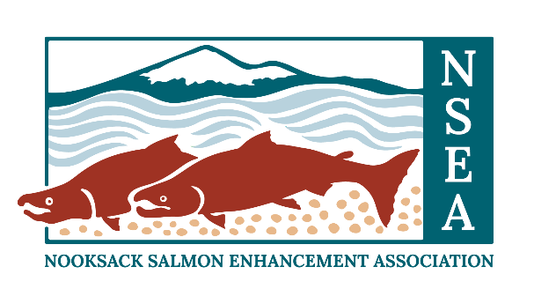
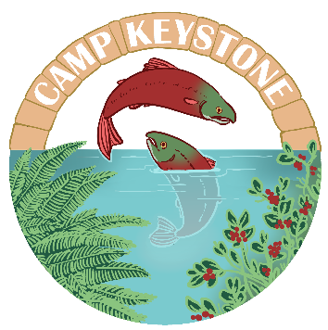

Camp Keystone FAQ’s

- How old does my child need to be to attend Camp Keystone?

Fishing Camp is targeted for campers entering 6-8 grade this fall. If your child is outside of this range (within reason), please contact Nathan at nzabel@n-sea.org. We will consider these on a case-by-case basis.

- How many campers are in the group? What is the adult to camper ratio?

The group of camp will have a maximum of 8 campers with 2 adults for a ratio of 1:4 adult to camper

- What is the minimum number of campers required to run a camp?

5 campers are required to run each session of camp. If this number is not met two weeks in advance of the camp starting, we will either cancel it and transfer your registration to the other session (if available), or refund you in full.

- Can I enroll my camper in both sessions of camp?

We don’t encourage enrollment in both sessions of camp, because the structure and content will be the same for each session. We encourage you to register for one session to leave space for other families to register.

- Do you offer a waitlist for full camps?

Yes! If a camp is full, you can still register for it and will be placed on a waitlist.

- Do you offer scholarships to attend camp?

Yes! Scholarships are available, dependent upon funding. You can apply for a scholarship during registration.

- What is your cancellation policy?

Cancellations must be made at least two weeks prior to the camp’s start date. We can move you to the other session, as space allows, or refund your registration (minus the 10% non-refundable deposit). Cancellations made less than two weeks in advance will result in no refund.

- Where is Camp Keystone located?

Camp Keystone is located on NSEA’s campus at 3057 E. Bakerview Rd., Bellingham, WA. Drop off and pick up will take place there.
Each day, we will be transporting campers to various field locations, such as parks to practice casting, restoration project sites, and fishing locations along local waterways.

- Can I attend Camp Keystone with my camper(s)?

No. Camp Keystone is an opportunity for your camper to develop skills such as independence, teamwork, and social emotional learning.

- What does a typical day of camp look like?

No two days are alike at Camp Keystone, but this sample schedule gives you an idea of activity types and daily flow. Activities will be a mix of fish identification, fly casting, fly tying, water quality testing, stewardship projects, and fishing.

9:00am Welcome and salmon circle
9:20am Transportation to field location
9:45am Snack
10:00am Outdoor activities
12:00pm Lunch
12:30pm Outdoor activities
2:30pm Snack
2:45pm Outdoor activities
3:30pm Transportation back to NSEA
3:45pm Closing circle
4:00pm Goodbye, see you soon!

